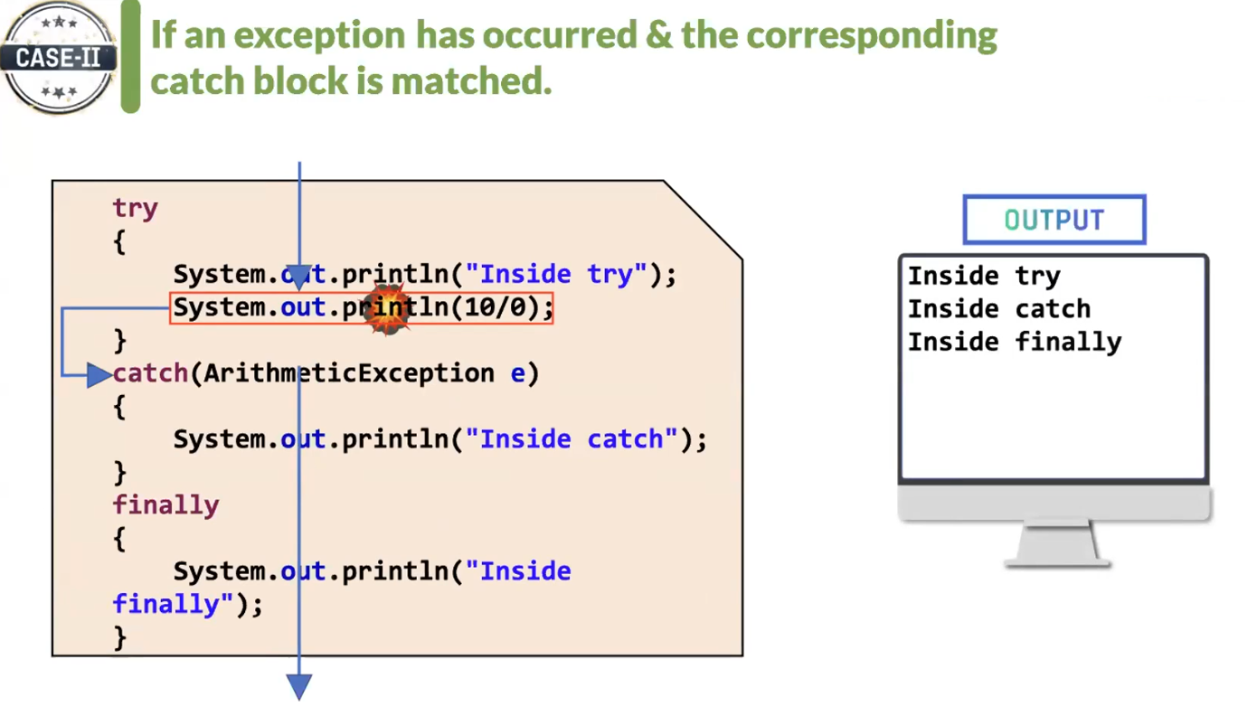

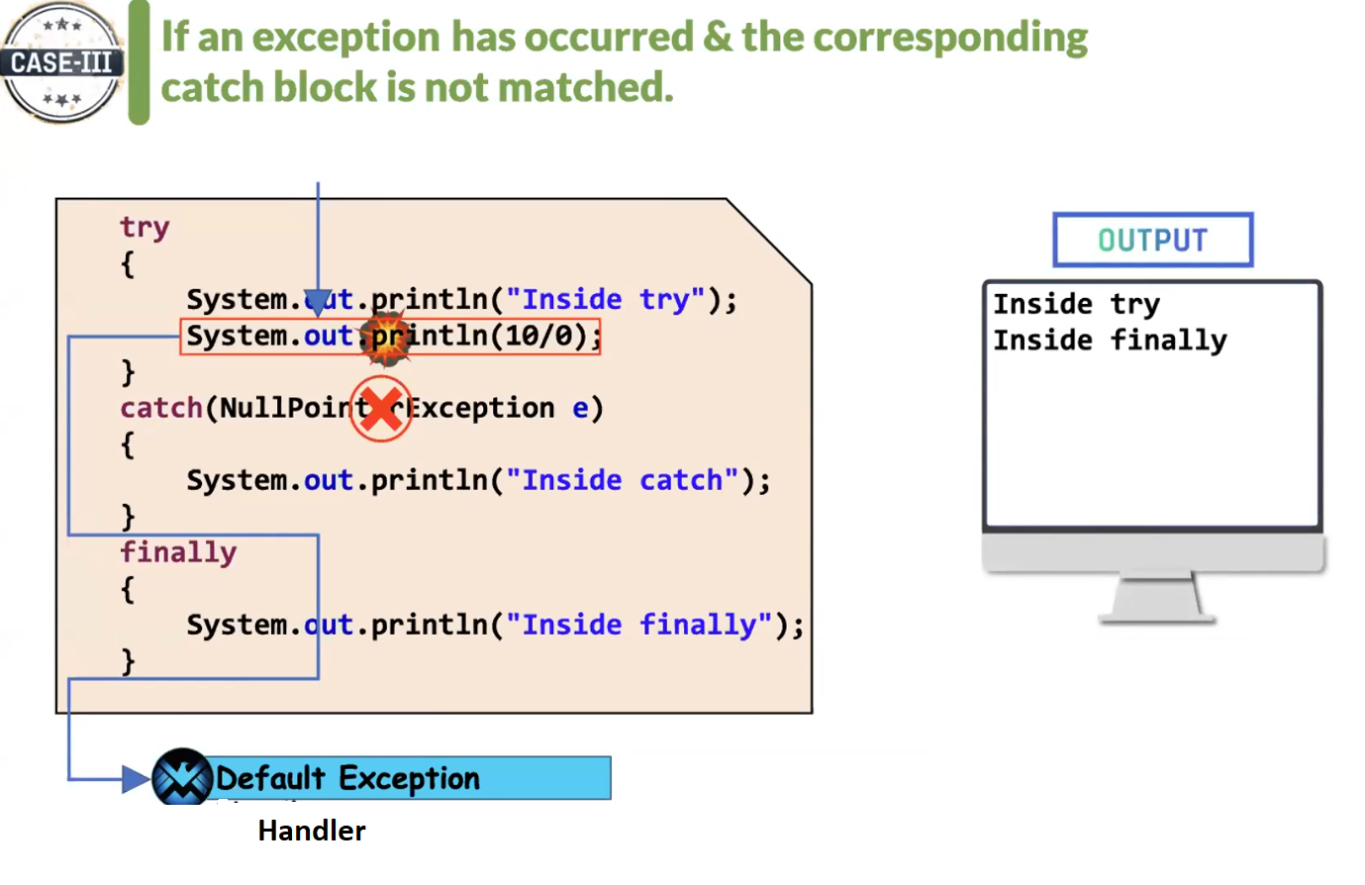

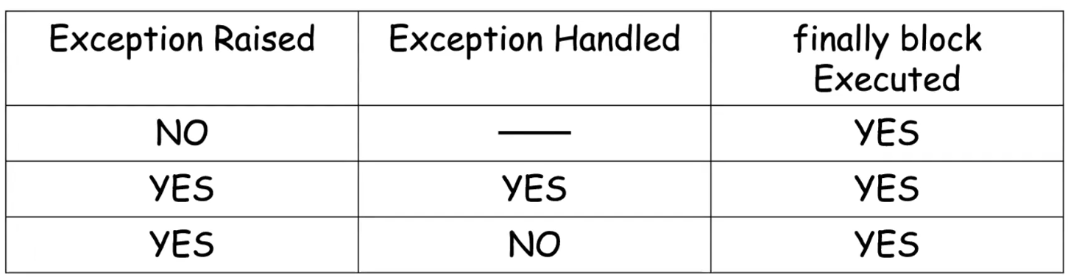

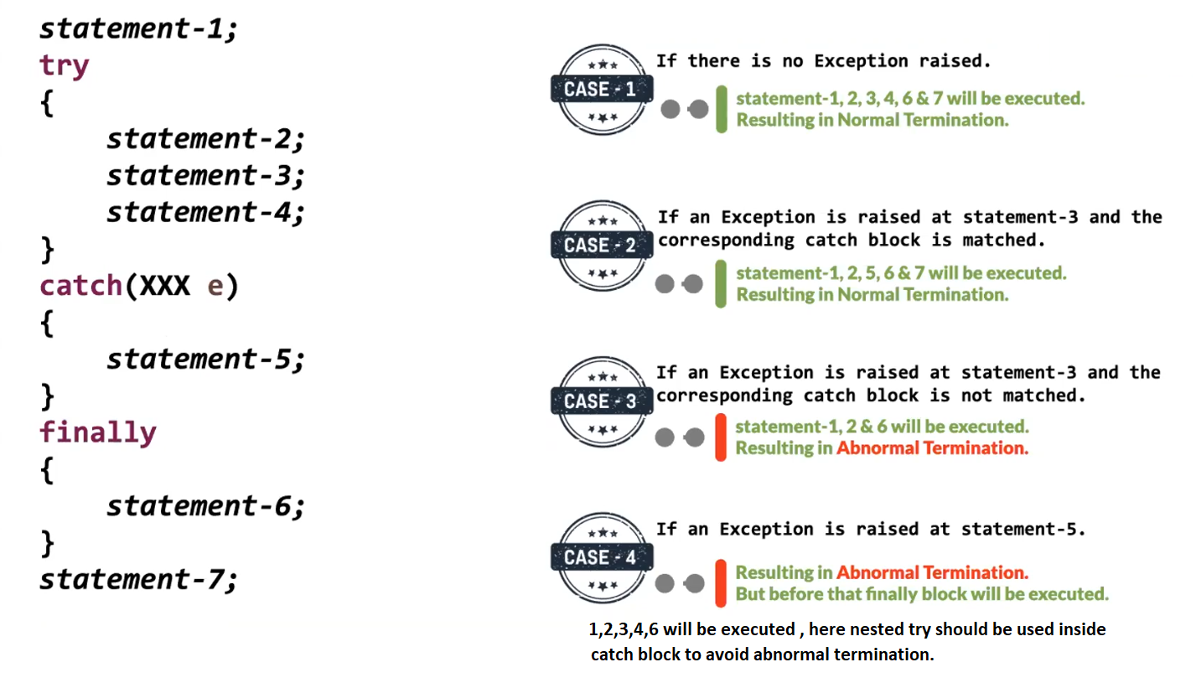

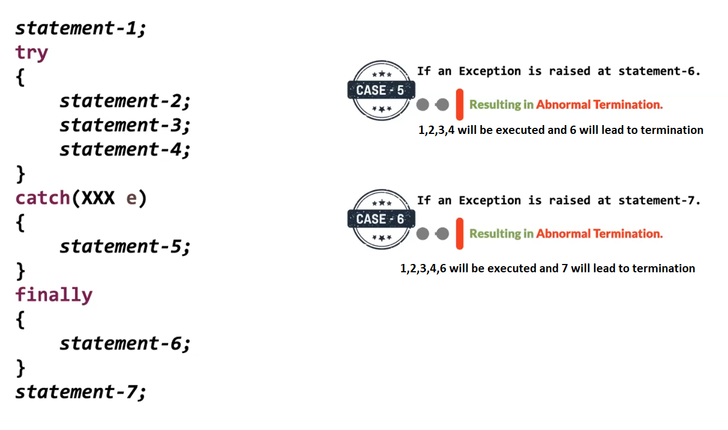

All the classes of exception are present in java.lang package

Partially checked exception:

It is such a parent Exception class where its child consists of both checked and unchecked exception classes.

If it is a partially checked exception it should be handled compulsorily

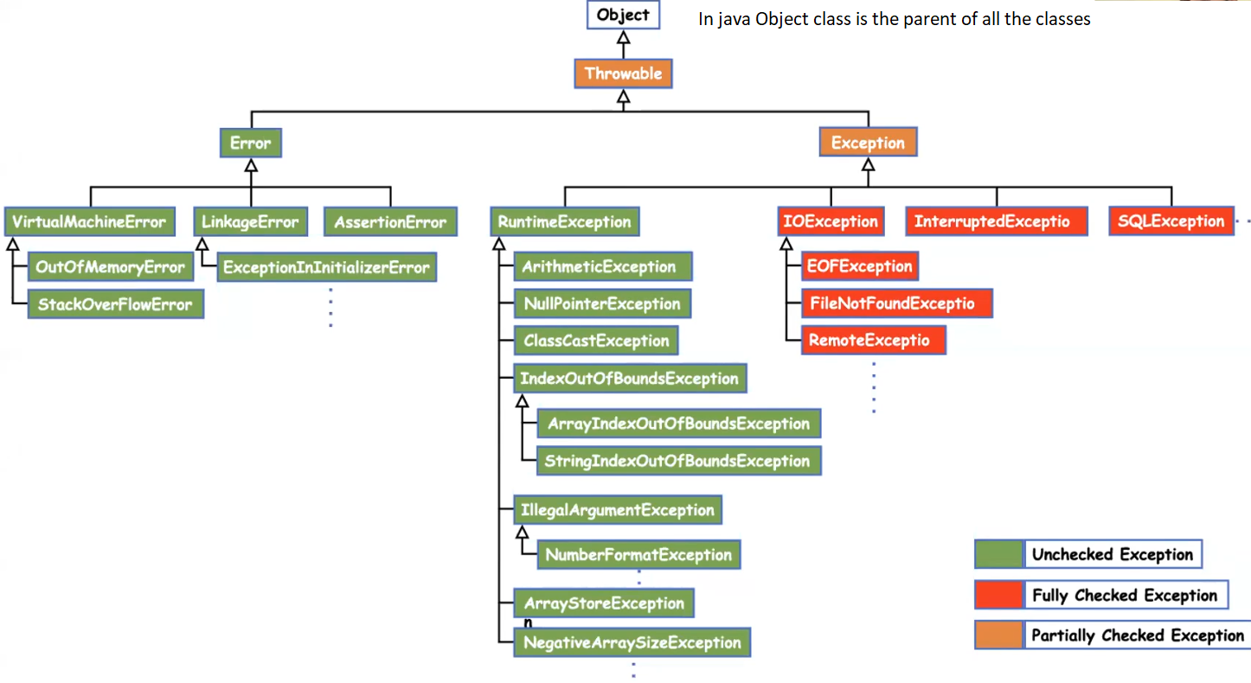

Nested try-catch example

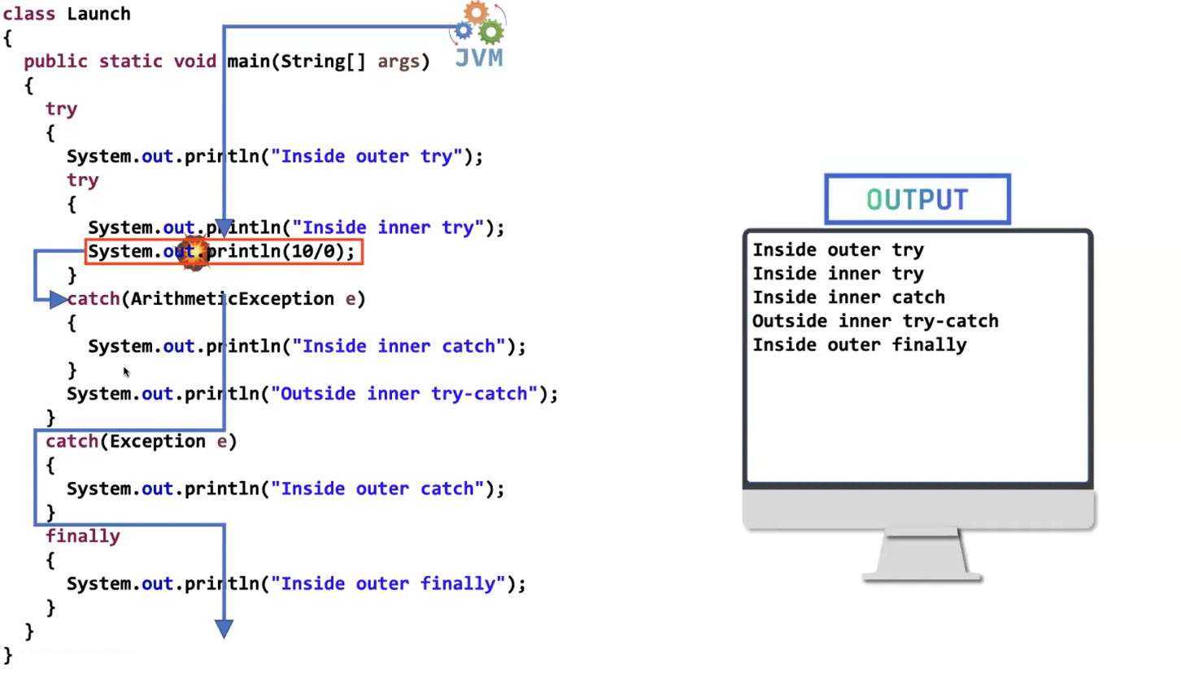

We can write another try-catch in “inside inner try”.

Similarly we can write another try catch in “inside inner catch”.

Even in the finally block also we can write try-catch.

We can write any number of times nested try - catch there is no restriction.

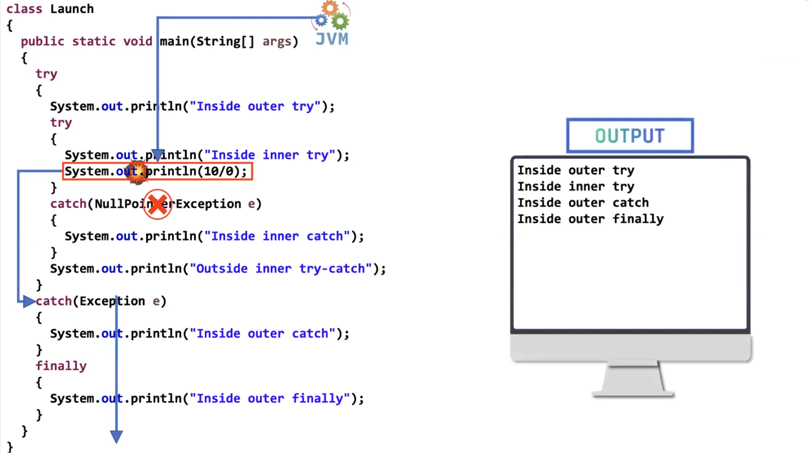

If inner catch block doesn’t handle the exception, it can be handled by the outer one. if outer catch also cannot handle then default exception handler comes into picture.

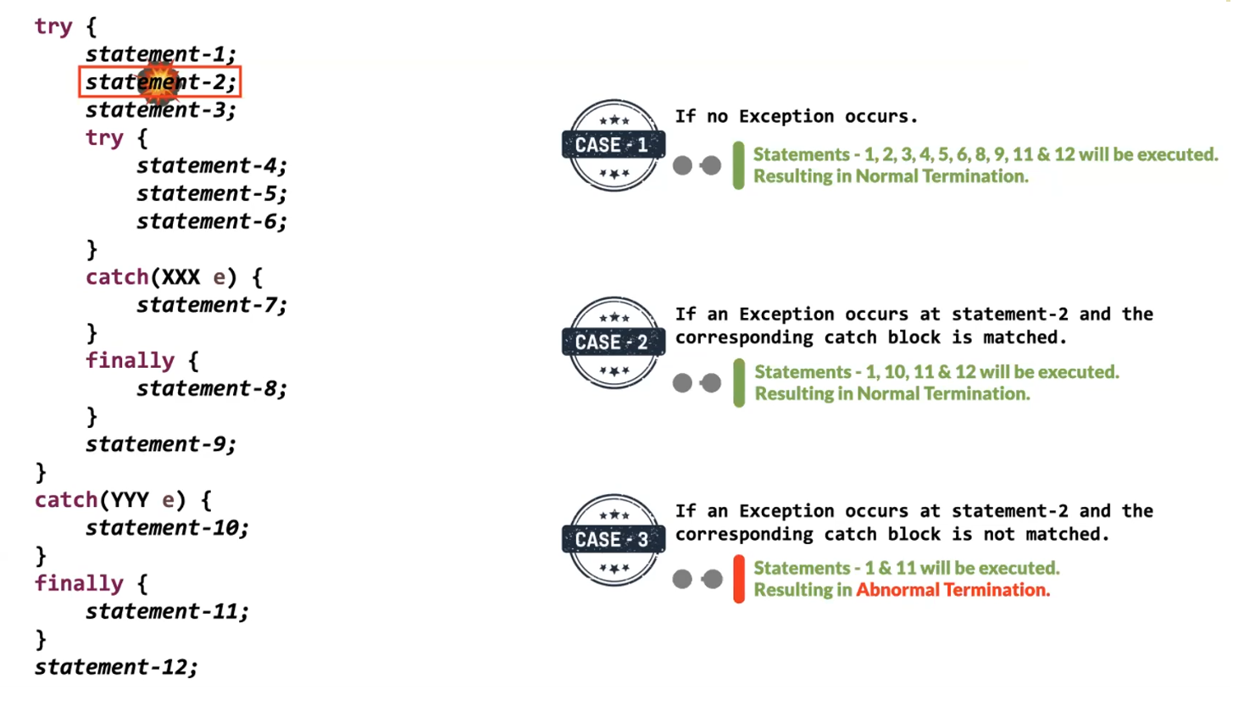

Note: finally block will be executed every time irrespective if exception arised (or) not, handled (or) not.

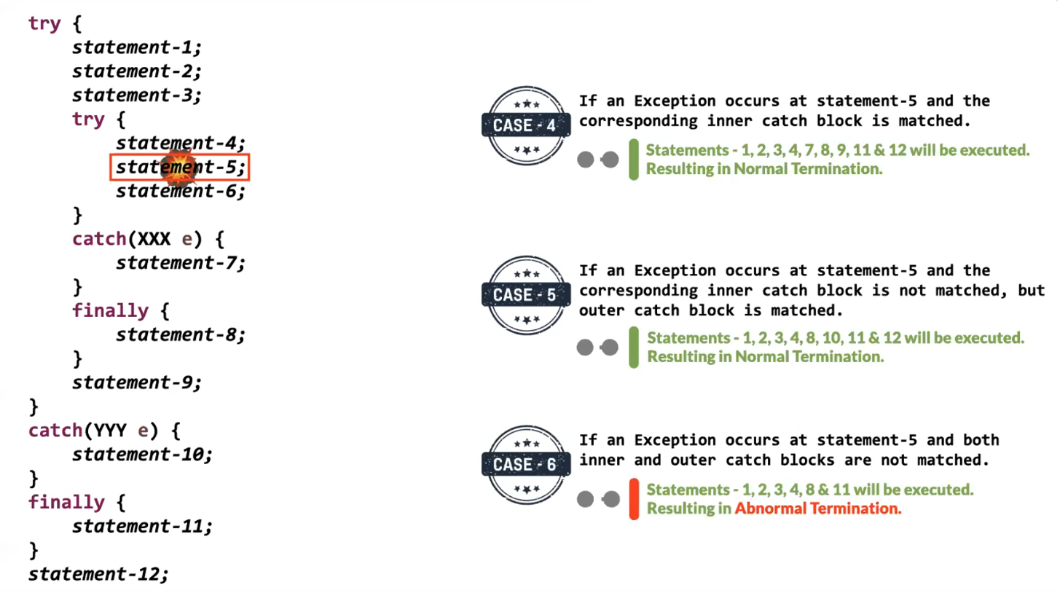

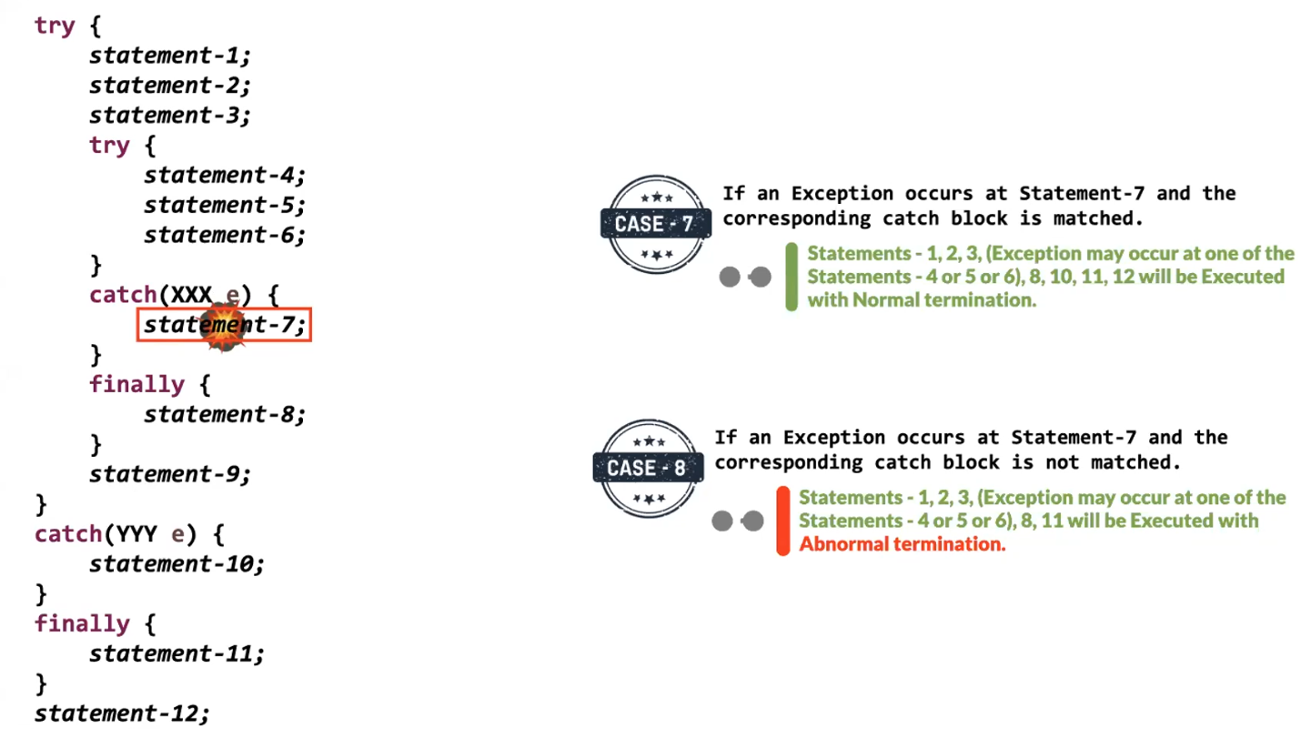

Eg: Exceptional_Handling_Case_9

// go through the code

Eg: Excaptional_Handling_Case_10

// go through the code

Possible allowed syntax for try – catch, finally block.

